Falkirk Council

Biodiversity Duty Report 2011-2014

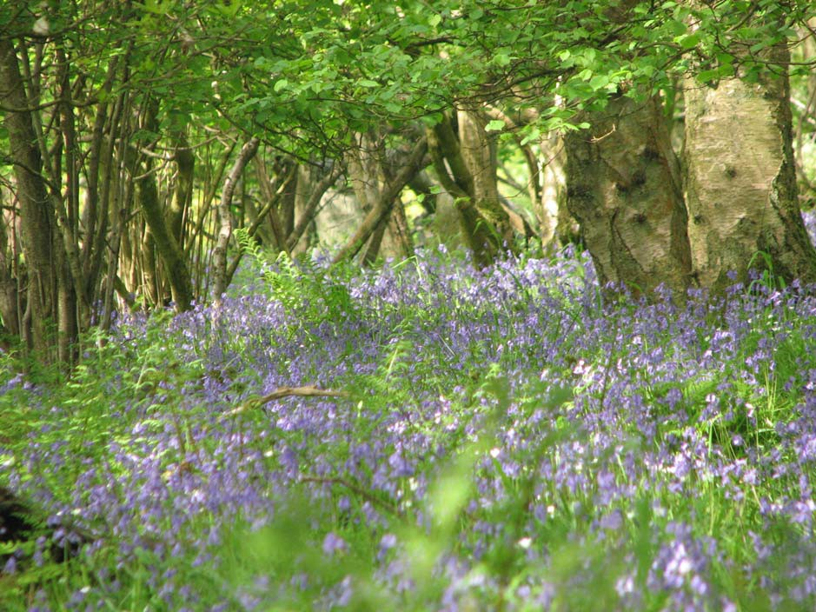

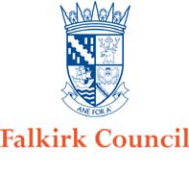

Nature Conservation (Scotland) Act 2004

Biodiversity Duty Report 2011-2014

Council Name | Falkirk Council
Reporting Period | 2011-2014

Introduction

Section 1.1 of the Nature Conservation Scotland Act (2004) states that “It is the duty of every public body and office-holder, in exercising any functions, to further the conservation of biodiversity so far as is consistent with the proper exercise of those functions”. This requirement is known as the Biodiversity Duty.

The Wildlife and Natural Environment Act (2011) requires all public bodies to report on their delivery of the Biodiversity Duty. Reports are to be produced and made public every three years.

This document reports on Falkirk Council’s delivery of the Biodiversity Duty for the period 2011-2014.

It addresses the following key themes:

- Governance – providing clear leadership and management on biodiversity.

- Mainstreaming – integrating biodiversity into corporate projects, plans and strategies.

- Action – taking action to protect and enhance biodiversity.

- Challenges and next steps.

This report is based on the knowledge of key personnel with a remit for biodiversity conservation within Falkirk Council and responses to a questionnaire sent to representatives within all services between August and September 2014.

This report will be made available on the Council’s website (www.falkirk.gov.uk), a copy can be requested from the Council’s Biodiversity Officer (E-mail: biodiversity@falkirk.gov.uk , Tel: 01324 504950), and a paper copy will also be available to view at Development Services, Abbotsford House, David’s Loan, Falkirk, FK2 7YZ.

Governance, Leadership and Management Governance
Overall governance is provided by the elected Members of Falkirk Council. All policies and key strategies are reported to Council for discussion and approval. Environmental policies and initiatives will usually be reported to the relevant Council committee. Progress on delivering the Local Biodiversity Action Plan and on other key environmental initiatives is reported to Council on a regular basis.

Leadership

Individual Councillors provide visible leadership with regard to environmental issues, relevant to their ward and/or their remits and responsibilities. For example:
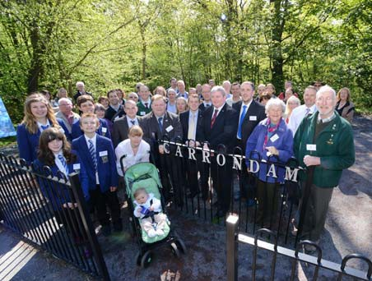
  - Attending environmental events, e.g. celebrating Local Nature Reserves.
  - Supporting environmental initiatives such as the ‘Where Have You Bean Geese?’ schools project.
  - Attending community environmental events such as the ‘Scottish Rivers Expo’.
  - Supporting key environmental policies or programmes within the Council such as the Local Biodiversity Action Plan or the Green Network Strategy.

In addition the Chief Executive of Falkirk Council and relevant Directors and Heads of Service have also recognised the importance of environmental initiatives and given their support to a wide range of programmes and events.

Management

The Corporate Sustainability Group, chaired by the Director of Development Services, has a remit to ensure that the Council meets its obligations under the Climate Change Scotland Act - this includes carbon reduction, adaptation, and sustainability (of which biodiversity conservation is a key element). Every Service within the Council is represented on the group by a senior member of staff. This provides a mechanism for integrating and championing sustainability issues and initiatives throughout the whole Council from the top down.

While the sustainability group has to date tended to focus more on issues of climate change, carbon reduction and sustainable resource use, it does provide a vital mechanism that may be used to ensure all services are aware of their responsibilities under the Biodiversity Duty and are integrating biodiversity conservation into their operations.

Additional cross-service groups which can champion and contribute to the conservation of biodiversity by Falkirk Council include:
- Green Network Strategy Group.
- Carbon Management Group.
- Open Space Strategy Group.

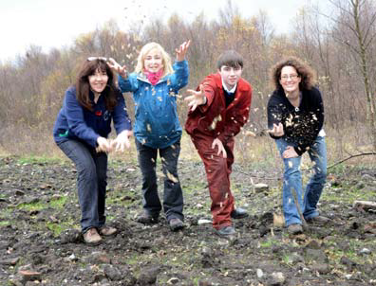
Within Falkirk Council Development Services takes a lead role in delivering the Biodiversity Duty. The Biodiversity Officer post, seated within Planning and Environment, has a specific remit to further the conservation of biodiversity through delivery of the Local Biodiversity Action Plan process. The Biodiversity Officer also provides expert advice, guidance and support to Council Services to assist and encourage actions to further the conservation of biodiversity, in line with the Biodiversity Duty.

Mainstreaming

Guiding principles and outcomes

The Council’s vision and aspirations for the area are outlined within both its Single Outcome Agreement and Strategic Community Plan. How the Council will work to deliver this vision is outlined within its Corporate Plan. All three documents recognise the importance of enhancing the quality of our environment.

Single Outcome Agreement
The Council’s Single Outcome Agreement (SOA) 2013-15 focuses its attention on the area’s greatest challenges. However the Community Planning Partnership, who developed the SOA, also highlight their commitment to pursuing “other important environmental outcomes as well as core service transformation”.

The SOA’s vision includes that ”we will be healthier and live longer”. Key local strategic drivers towards this vision include the Biodiversity Action Plan.

Within the health theme, key activities for delivering mental well-being include “maintenance and protection of the variety of flora and fauna in our local environment, for the benefit of our communities”.

The Strategic Community Plan 2010-15 states that:
“If people are to use our parks, paths and open spaces then they must be attractive places to visit. With the increase in people using our open spaces, we have also to be aware that we need to protect some vulnerable species and ecosystems. Our area with its marshlands provides a significant eco system for wildlife.”

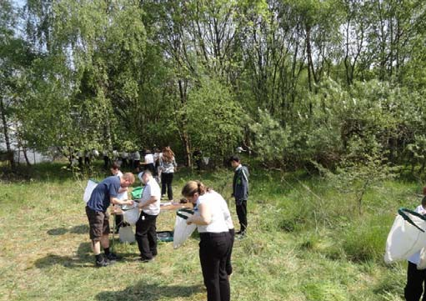
Falkirk Council Corporate Plan
A key goal within Falkirk Council’s Corporate Plan is “enhancing and sustaining an environment in which people want to live and visit”. The plan states that:

- “We will be greener
- We will improve the built environment
- Our open spaces will be attractive, accessible and safe
- Our profile will reflect our area as a destination of choice”.

Plans, policies and strategies

It is essential that biodiversity conservation is incorporated into relevant plans, policies and strategies, if it is to be delivered effectively across the Council. Council plans, policies and strategies which are particularly key to furthering the conservation of biodiversity include the following:

Local Biodiversity Action Plan
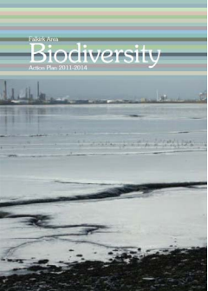
The Council is a key partner in the Local Biodiversity Action Plan process, which is co-ordinated by the Council’s Biodiversity Officer. This process aims to identify and deliver focused local action to conserve biodiversity. Input from Falkirk Council to this process is critical to achieving the goal of safeguarding our vital local biodiversity. Playing this key role in the LBAP process is a fundamental element of the Council’s fulfilment of its Biodiversity Duty.

The Falkirk Council Area has had a Local Biodiversity Action Plan process since 2000, supported by a Biodiversity Officer within Falkirk Council. Within the current Falkirk Area Biodiversity Action Plan 2011-14 over half of the actions relate to Council owned land or Council initiatives. What’s more Falkirk Council is a key partner in the delivery of over two thirds of the remaining actions. The co- ordinating role of the Council’s Biodiversity Officer is critical to the delivery of these and other biodiversity conservation activities within the local area.

The Council’s Environmental Policy
Falkirk Council’s Environmental Policy states: “Falkirk Council will conduct its business responsibly, in a way that protects the environment, actively prevents pollution and protects the health and safety of employees, visitors and local residents. Wherever it operates, it will conduct business with respect and care for both the local and global environment. It will aim to lead by example, promoting the values endorsed in this statement and co-ordinating action in the wider community.

The policy lists a number of standards and actions which the Council is committed to, including to:
- “use natural resources in a more sustainable way and aim to protect and enhance Falkirk’s wildlife and biodiversity on land managed by the Council;
- comply with all relevant environmental legislation and regulations, codes of best working practice and other recognised requirements;
- protect and enhance the natural and built environment;…”.

Other plans and policies which promote the protection and conservation of biodiversity include:

  - Sustainable Development and Climate Change Strategy 2012-2017 and Action Plan 2013-15.
  - Green Network Strategy.
  - Local Development Plan
  - Falkirk Open Space Strategy.

Various other plans, policies and strategies take account of their potential impact on biodiversity and seek to minimise negative impacts.

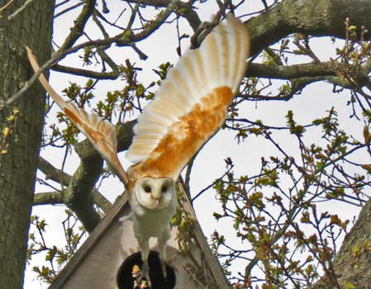
Procedures and processes

Specific procedures are adopted by some Services or parts of Services to ensure that they routinely assess the effects of their activities on biodiversity, adhere to environmental law and adopt environmental good practice. In some cases this is undertaken on a project by project basis rather than assessing the impacts of wider policies or strategies. However, in some instances where impacts on biodiversity may be considered this is done on an ad hoc basis and tends to rely on the awareness and understanding of the individual staff involved.

Procedures used by some Services to assess and limit impacts on biodiversity include:
  - Strategic Environmental Assessment (undertaken by units within two Services).
  - Consultation with the Biodiversity Officer or similar expert.
  - Use of ecological consultants.
  - Environmental Impact Assessment (where legally required).
  - Pre-works ecological surveys.
  - Contractor and procurement standards or requirements.

Advice and Expertise

The majority of Council Services seek biodiversity advice from the Council’s Biodiversity Officer or, in some instances, from external organisations or specialist consultants. Other staff within the Planning and Environment Unit, such as the outdoor rangers, also provide expert advice to colleagues on biodiversity conservation.

Some Services have staff with specific responsibility for and knowledge of biodiversity conservation issues. However, most rely on a general awareness of environmental issues by those staff whose remit it is most relevant to and access expert advice and support from elsewhere within the Council or externally as required. The availability of this advice and support is constrained by the level of specialist staff resource dedicated to biodiversity conservation and ecological issues.

Whilst several Services report not having provided biodiversity related training to staff members, those Services most likely to regularly impact on biodiversity have provided a range of relevant biodiversity training to some staff.

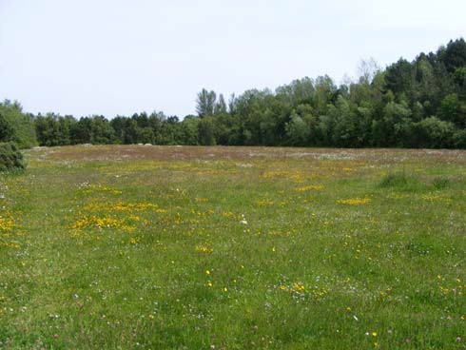
Staff Awareness

Staff awareness of the biodiversity duty within Falkirk Council is generally low. However, there is greater awareness of more general environmental issues, opportunities and constraints. These include: environmental legislation, species protection, invasive species, and sustainable procurement. Similarly awareness of the Council’s Environmental Policy appears to be limited but there is greater awareness of the environmental policies and initiatives most relevant to individual or Service remits.

Action for Biodiversity

This section highlights the wide variety of activities undertaken by Falkirk Council to further the conservation of biodiversity over the reporting period (2011-14). While not exhaustive, it illustrates the range of activities that have taken place and continue to take place.

Adhering to environmental law
  - Development of a checklist to ensure contractors undertaking replacement fencing works are checking hedges for nesting birds and other wildlife prior to removing the hedge. This has been undertaken with support from the Biodiversity Officer who also met with contactors during the procurement process. (Corporate & Neighbourhood and Development Services).
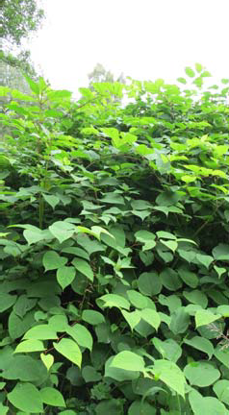
  - Protected species surveys undertaken at potential cemetery extension sites, early on in the design process (Corporate & Neighbourhood Services).

  - Appropriate ecological surveys and assessment required with planning applications likely to impact on protected biodiversity (Development Services).

  - Japanese Knotweed surveys and control undertaken at the Slamannan Road Car Park site and Coney Park bus turning area prior to construction work commencing (Development Services).
  - Work on the Blackness to Bo’ness footpath scheduled to avoid disturbance to birds wintering within the Firth of Forth SPA. All trees to be removed during construction surveyed for bat roosts prior to work starting. (Development Services).

  - Consultant appointed to undertake bat roost surveys in house re-roofing project at Whitecross (Corporate & Neighbourhood and Development Services).

  - Work within rivers and burns scheduled to avoid fish spawning and migration periods (Development Services).
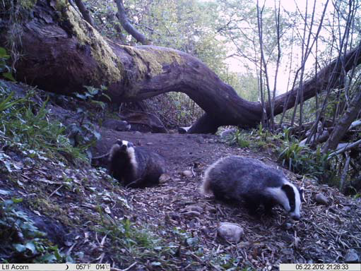
    - Biodiversity is included in framework contracts for term consultants for engineering and flooding, providing expertise in ecological issues during project design and planning. (Development Services).

    - Protection of a bat roost within a Social Work building (Social Work Services).

Assessing and limiting negative impacts
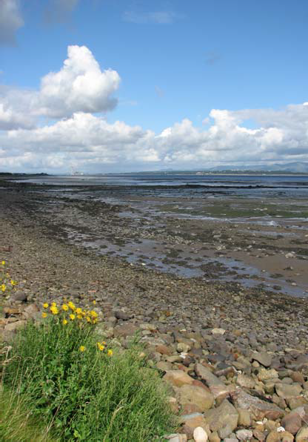
  - Annual contact is made with Services to remind them of the need to undertake Strategic Environment Assessments of all plans, programmes and policies. (Development Services).
  - Full Strategic Environmental Assessments have been undertaken on key strategy/policy documents including the Council’s Local Housing Strategy, the Local Development Plan and the Local Biodiversity Action Plan. (Corporate & Neighbourhood and Development Services).

  - Habitat Regulations Assessments are undertaken for any projects likely to have a significant impact on Special Protection Areas (designated for their important bird populations). As the competent authority Falkirk Council undertake a significant number of these assessments. In addition several of its own policies have been subject to assessment e.g. the Local Development Plan. (Development Services).

Promoting environmental best practice
  - Contractor’s constructing the new Dorrator Bridge required to implement suitable bio-security measures due to the presence of Japanese Knotweed. (Development Services).
  - Procurement ensure that all timber purchased by Falkirk Council must meet specific sustainability criteria. The timber accreditation schemes ensure parts of the source forests are protected entirely to protect rare animals and plants. Falkirk was the first Scottish Council to achieve WWF gold accreditation for the sustainable procurement of timber. (Corporate & Neighbourhood Services).

  - Native trees have been planted along the line of the new cycleway at rear of Denny High School. (Development Services).

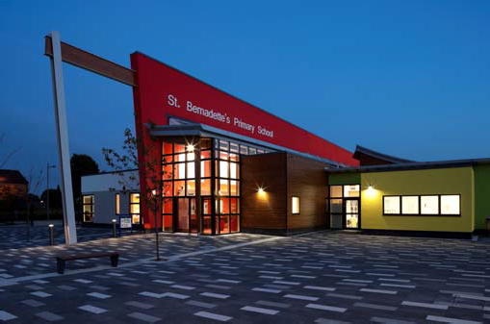
    - Building Design provided an options appraisal for Housing for developing new housing to an enhanced (silver) level of sustainability under the technical standards. (Development Services).
    - St Bernadette’s Primary School was designed to meet BREEAM ‘very good’ standards. BREEAM standards include consideration of ecological impacts. (Education and Development Services).

  - Street lighting is designed and located to reduce negative impacts on biodiversity. (Development Services).
  - The M876 Glenbervie slip road construction was designed and undertaken to retain mature trees where possible. (Development Services).

Positive action to conserve biodiversity
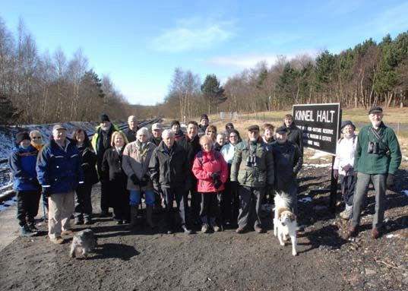
  - Services work with and support a wide range of local community groups to enhance and protect various Council owned sites of value for wildlife, including: Westquarter Glen, Bonnyfield Local Nature Reserve, Polmont Woods, Maddiston Valley Park, Carron Dams Local Nature Reserve, and Kinneil Foreshore Local Nature Reserve. (Corporate & Neighbourhood and Development Services).

  - Control of invasive species (especially Japanese knotweed and giant hogweed) is undertaken on Council owned land and at a number of other strategic locations. (Corporate & Neighbourhood and Development Services).
  - Estates Management have supported the creation of 6 community gardens, two with a focus on biodiversity. (Corporate & Neighbourhood Services).

  - Staff and children at Tremanna Residential Home have worked to revitalise their garden. (Social Work Services).

  - The improvement and management of the Stenhousemuir Lido has been on-going to ensure that the pond is an attractive feature and a valuable haven for local wildlife. (Development Services).
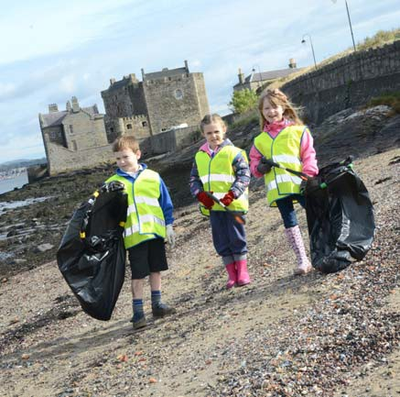
  - Since 2011 the Council has designated two further Local Nature Reserves at Kinneil Foreshore and Carron Dams, to complement its first LNR at Bonnyfield Nature Park. All are actively managed by local groups with Council support. (Development Services).

  - The litter team have biodiversity as one of their main objectives and the orphan land project has undertaken work to protect and enhance biodiversity. (Corporate & Neighbourhood Services).

  - There are bird feeding stations at a number of care homes, while Cunningham House has a specific wildlife friendly area in its grounds. (Social Work Services).

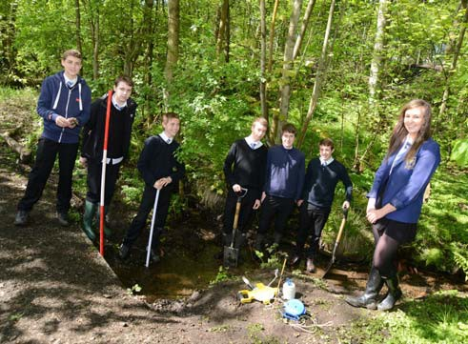
    - Larbert High School is working closely with conservation organisations and the local community to protect and enhance the Carron Dams Local Nature Reserve and to use it for learning across the curriculum. The school won the RSPB’s Nature of Scotland Award ‘Education category’ 2013 for their work. (Education and Development Services).
    - The new Denny War Memorial Garden includes wildlife planting,
habitat piles and wildlife interpretation boards. (Development Services).
  - All trees on land owned by Housing have been surveyed and labelled, and appropriate management identified and prioritised. Development Services are starting a similar audit of trees on their land. (Corporate & Neighbourhood and Development Services).

  - The unpaid work team have contributed to a wide range of environmental projects, including working to restore the walled garden at Dollar Park with service users of the joint dementia unit. (Social Work Services).
  - Work to upgrade areas of open space on Housing land has identified areas suitable for biodiversity enhancements such as planting wildlife friendly bulbs. (Corporate & Neighbourhood Services).

  - Natural flood management projects have been undertaken which deliver wildlife benefits. (Development Services).

  - The Local Biodiversity Action Plan process delivers a wide range of local biodiversity projects on Council land or with the direct support of council staff (including the Biodiversity Officer). Since 2011 these have included:
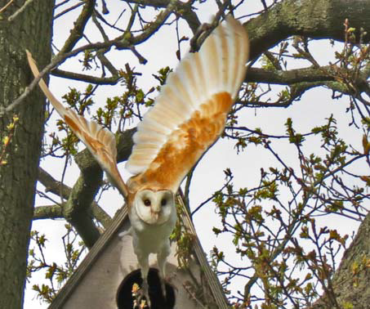
- management of a number of ecologically important sites,
- tree sparrow and barn owl conservation,
- great crested newt monitoring,
- pond conservation,
- development of a bog restoration group,
- management of brownfield sites including Forge Dam,
- a Falkirk Invasive Species Forum to raise awareness of, monitor and control invasive species,
- management of a rare orchid population,
- a review of locally designated sites and identification of potential new sites, and
- work to conserve the wintering bean goose flock.

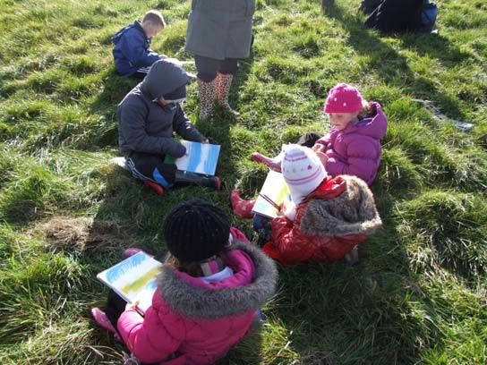
  - Slamannan Primary School has completed the ‘Where Have You Bean Geese?’ project, working to understand and appreciate the unique flock of bean geese that winter nearby on the Slamannan Plateau. (Education and Development Services).
  - The Council protects over 80 locally designated wildlife sites and sites of importance for nature conservation. Management plans have been produced and are now being implemented for a number of designated sites owned by Falkirk Council. (Development Services).

  - Falkirk Council is a key partner in the Inner Forth Landscape Initiative and delivering a range of biodiversity projects as part of the initiative. (Development Services).

  - Staff at Sealock House transformed an outdoor space in to an Eco Garden improving the working and social environment. (Education supported by Corporate & Neighourhood and Development Services).
  - Several parks have recently benefited from biodiversity enhancements such as meadows, orchards, native tree planting and removal of invasive species. Additional areas are being identified for further biodiversity enhancements in a number of parks. (Corporate & Neighbourhood Services supported by Development Services).

  - Several tenants and residents associations are being supported to enhance their local area and promote biodiversity, by encouraging planting of a range of plants and shrubs. (Corporate & Neighbourhood Services).

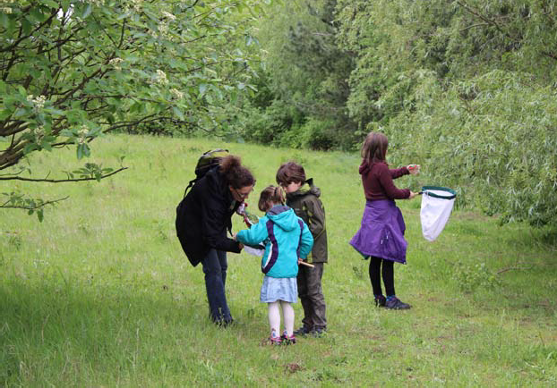
    - The Outdoor Rangers deliver a wide range of biodiversity projects
including: schools grounds enhancements, meadow creation, site management, environ- mental education and interpretation, and species surveying and protection. They also support the Falkirk Wildlife Volunteers group who undertake barn owl and tree sparrow next box projects and tree sparrow feeding. (Development Services).

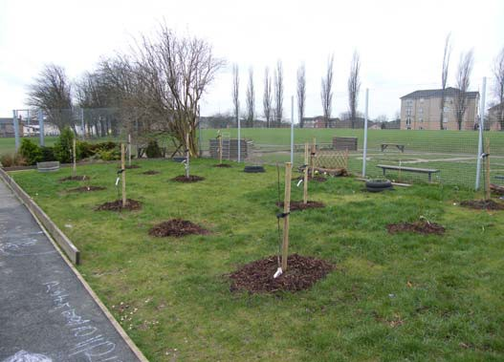
  - Many community groups have been supported to undertake a wide range of local environmental projects. (Development, Corporate & Neighbourhood and Education Services).
  - Several schools have planted and continue to care for orchards within their grounds. (Development and Education Services).

  - Falkirk Council’s Greenspace project received the Scottish RTPI Quality in Planning Award (2012) and has more recently been awarded the Scottish Green Apple Award, with Falkirk Council announced the overall winner of the Scottish Green Apple award 2014. The Council has also won gold at the UK Green Apple Awards 2014 for its support for the Helix project. (Development Services).

  - 86 Falkirk schools and nurseries are registered with Eco-schools. 52 of these have green flags, 59 have silver awards and 66 have bronze awards. (Education Services).

Advice, Training and Sharing Good Practice
  - A series of lunch-time training seminars have been provided by the Biodiversity Officer for Development Services staff on topics such as protected species, invasive non-native species, climate change adaptation and brownfield biodiversity. (Development Services).

  - Training sessions on invasive non-native species identification and control given to Estates Management, who are now producing their own identification guide with support from the Biodiversity Officer. (Corporate & Neighbourhood and Development Services).

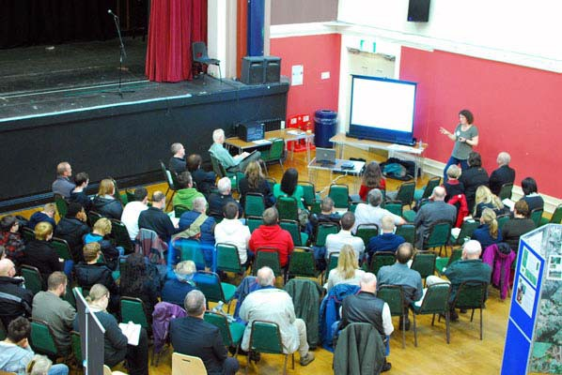
    - Biodiversity training and awareness raising amongst staff at Larbert High School to help them make the most of the neighbouring nature reserve with pupils. (Education and Development Services).
    - Procurement staff have received Marrakech Task Force training on sustainable public procurement, including biodiversity issues. (Corporate &
Neighbourhood Services).
  - Dialogue between Estates Management staff and the biodiversity officer and outdoor rangers has informed work to enhance and protect biodiversity in parks and on orphan land project sites. (Corporate & Neighbourhood and Development Services).

  - Street lighting staff have undertaken Institution of Lighting Professionals (ILP) training covering biodiversity issues. (Development Services).
  - The Biodiversity Officer and other Planning and Environment Unit staff provide expert advice on biodiversity issues to colleagues within Falkirk Council. (Development Services).

  - The Biodiversity and Development Supplementary Guidance has been reviewed and updated. It provides advice to developers on the ecological opportunities and constraints they must consider. Supplementary Guidance covering Local Nature Conservation Sites is in production. (Development Services).

  - Staff are encouraged to attend relevant biodiversity training courses provided by other organisations such as Scottish Natural Heritage. (Development Services).

Awareness raising, communication and education
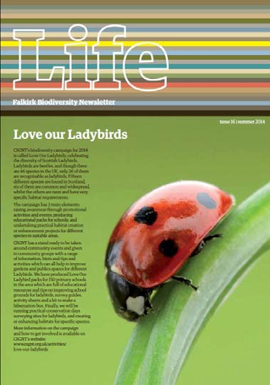
    - The Falkirk Biodiversity Newsletter is produced twice a year and circulated to elected members, other Council staff, and relevant organisations and individuals, and made available to members of the public. (Development Services).

    - The outdoor ranger’s work with schools and community groups, programme of public events, provision of site interpretation and Outdoor Diary programme promotes a wide range of opportunities for people to discover local biodiversity and find out more about it. (Development Services).

    - Falkirk Council supports a variety of initiatives to promote biodiversity and encourage people to learn more about it. These include: Naturefest, Forth Naturalist and Historian events, and community led events such as the Scottish Rivers Expo day, amongst others.
  - Falkirk Council has publicised its work on the procurement of sustainable timber to an international audience as well as to other local authorities, to promote best practice. (Corporate & Neighbourhood Services).

  - Several schools encourage pupils to become involved in the John Muir award scheme as a means of engaging them in environmental issues and activities. (Education Services).

  - The Transport Planning team meetings have a fixed agenda item on sustainability issues to ensure regular considerations of sustainability issues. (Development Services).

  - Housing staff are encouraging tenants to take small steps to benefit wildlife within their gardens (Corporate and Neighbourhood Services).

  - Social work clients are given the opportunity to learn about and enjoy wildlife and greenspace at Carron Fort (Social Work Services).
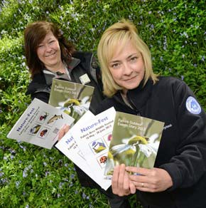
  - A range of guidance notes, leaflets, postcards and other materials have been produced to highlight biodiversity and raise local awareness of environmental activities. (Development Services).

  - The provision of a new cycle path is enabling school children from Bothkennar to safely access local open space for outdoor learning. (Development and Education Services).

Partnership working
Many of the above activities highlight the level of joint working that is taking place between Council Services to achieve biodiversity conservation. In addition Council Services are working closely with other organisations and community groups to further the conservation of biodiversity.
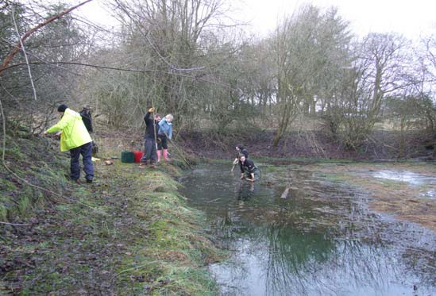
The Local Biodiversity Action Plan Partnership includes a wide range of conservation organisations and individuals, as well as Falkirk Council, and demonstrates the value of partnership working. Partnership working is critical to the delivery of local biodiversity conservation and the vast number of environmental partnership groups which the Council participates in makes it unfeasible to provide a comprehensive list in this report.

Challenges and next steps
The Wildlife and Natural Environment Act requires Falkirk Council to report every three years on its work to further the conservation of biodiversity. This first report is not only an opportunity to highlight the considerable range of biodiversity conservation activities that are already taking place, but also to highlight opportunities for improvement.
This reporting process has highlighted some potential next steps to further improve upon Falkirk Councils delivery of the Biodiversity Duty over the next three years. These include:

Governance, leadership & management
- Ensure that biodiversity issues and opportunities are included in the remit of the Corporate Sustainability Group.
- Determine the potential requirement and demand for biodiversity duty training or awareness raising amongst elected members and senior Council staff.

Mainstreaming

- Secure wider circulation of the Biodiversity Newsletter to relevant Falkirk Council staff, potentially with greater input from Council Services to news items.

- Determine the level of general awareness of biodiversity and biodiversity conservation across all Council staff.

- Ensure key staff within all services are aware of the biodiversity duty and how they can help deliver it.

- Maintain and fully resource the Biodiversity Office post, as a key mechanism for ensuring that Falkirk Council delivers it’s Biodiversity Duty across all Services.

Action

- Ensure that all contractors adhere to good practice with regard to environmental protection and bio-security. Review contractor pre-qualification requirements and contractual obligations if necessary.

- Ensure that expert biodiversity advice is available to all Council Services as required, and that staff members know when and where to seek expert advice.

- Implement the Inner Forth Landscape Initiative (HLF) range of projects in the Council area programmed 2014-19.

- Assist each Service to identify a small number of new biodiversity conservation actions to undertake during the period 2015-2017. Some Services have already suggested a number of specific activities e.g.

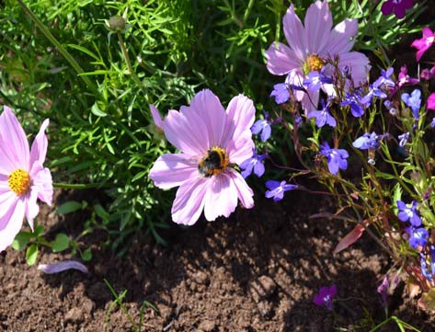
  - Provide biodiversity guidance within premises manuals.
  - Identify opportunities for creating green networks in association with infrastructure projects.
  - Incorporate biodiversity features or areas into a proportion of parks.
  - Identify a range of nectar-rich plants to benefit wildlife to grow in the Council nursery and trial in planting schemes.
  - Encourage residents groups to consider measures to benefit wildlife (possibly as part of wider environmental improvements).

